**Compiled 3CDMAS questions**

**Wizard’s solutions**

**Contents**

**Calculus  
Matrices  
Complex Numbers and Polar Coordinates  
Proofs  
Vectors  
Absolute Values  
Notes (not the kind of which you take 4 pages into the exam, but notes on a few of the questions. These questions are identified by an *)  
Version History**

**Calculus**

**Canning College 2010 S2 RF 8 c**  [4 marks]

Determine, in simplified form:

CodeCogsEqn (23)

**Canning College 2010 S2 RR 12** [4 marks]

Consider the function $P=2π$ $\sqrt{\frac{t}{5}}$

Use a calculus method to determine the error in calculating P if t is measured to be 3 ± 0.1

CodeCogsEqn (2)

**Canning College 2010 S2 RR 13** [1, 3, 2, 2 marks]

An object is moving along the *x* axis such that its velocity after *t* seconds is given by

$$v=2π\cos{4πt+4π\cos{2πt}}$$

Given the object is initially at $x=4$, determine:

The maximum velocity of the object

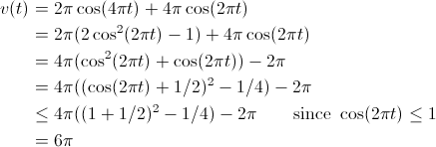

The time taken for the object to return to its starting position for the first time

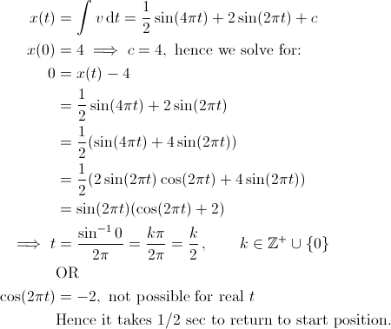

The distance the object travels in the first 0.1 seconds (use your calculator but indicate the method used)

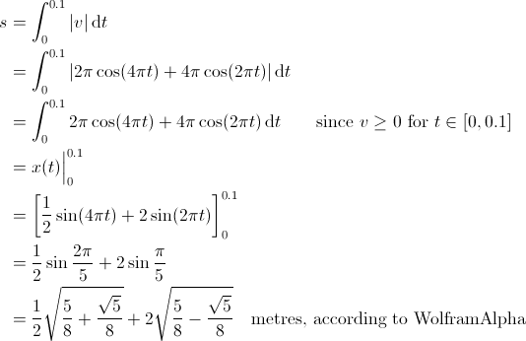

The acceleration of the object at t = 2 seconds

CodeCogsEqn (4)

**Edwest 2011 S2 RF 2 a i** [2 marks]

Find: du

CodeCogsEqn (5)

**Edwest 2011 S2 RF 6** [4, 2 marks]

Establish the inequalities $x\cos{x}< \sin{x} <x$ for $0<x<\frac{π}{2}$ using ideas related to the unit circle

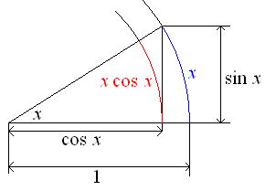

CodeCogsEqn (8)

Use the above result to establish $\lim_{x→0}{\frac{\sin{x}}{x}}$

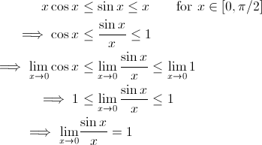

The original solution (with ‘less than’ instead of ‘less than or equal to’) is wrong, because  
1 < $\lim_{x→0}{\frac{\sin{x}}{x}}$ < 1 implies 1 < 1, a contradiction.

**Edwest 2011 S2 RR 10** [7 marks]

Police Forensic Investigators are called late at night to investigate a murdered person in a suburban house. To get an idea of when the person died, the investigators use Newton’s Law of Cooling which states that the rate of change of the temperature of a body is proportional to the difference between its own temperature and the ambient temperature (temperature of the surroundings). The investigators note the body’s temperature when they arrived at 3:15am was 17.4°C and at 4:15am was 15.0°C. To estimate the time of death, the investigators assume the room temperature that night remained a constant 10°C and that the person’s body had a temperature of 37.0°C at the time of death. Use Newton’s Law of Cooling and the supplied information to estimate the time of death to the nearest 5 minutes.

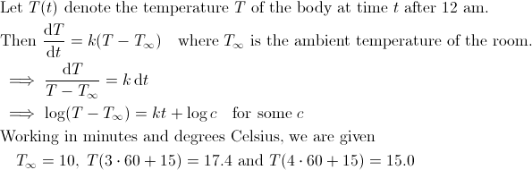

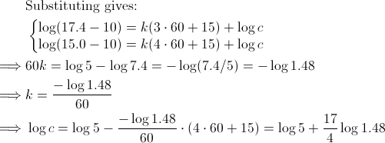

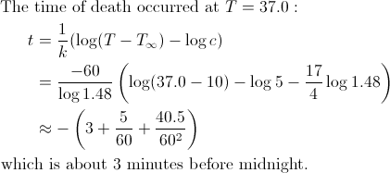

**Hale/St Mary’s 2012 S2 RR 9** [5, 3, 4 marks]

A ladder, 2 metres long, has its base on level ground and its top resting against a vertical wall. A ring is fixed 0.5m from the base of the ladder as shown below. The ladder starts to slip down at a constant rate of 0.1m/s when it is $\sqrt{3}$ metres up the wall.

How fast (exact value) is the foot of the ladder moving away from the wall initally?

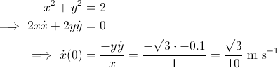

How fast is the ring moving down (vertically)?

CodeCogsEqn (13)

How far is the ladder up the wall when the ring is moving with a speed of m/s ?

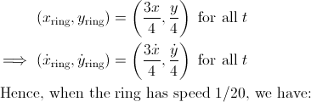

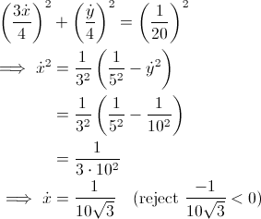

CodeCogsEqn (17)

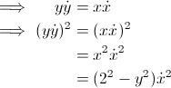

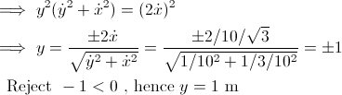

**Hale/St Mary’s 2012 S2 RR 16** [1, 4, 4 marks]

The diagram below shows the graph of $y=f(x)$ and the graph of its inverse function



$y=g\left(x\right)=f^{-1}(x)$

y = f(x)

y = g(x)

P(a, b)

gradient = m

A point P (a,b) is on the graph of $y=f(x)$.

The tangent at P has a gradient m.

State the value of

CodeCogsEqn (22)

Show that $g^{'}\left(b\right)= \frac{1}{m}$

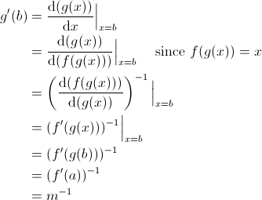

Find the coordinates of the point of intersection of the tangent at P and the tangent at $x=b$ on the graph of $y=g(x)$ in terms of a, b and m (assume $m≠-1$)

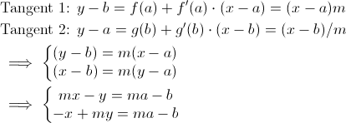

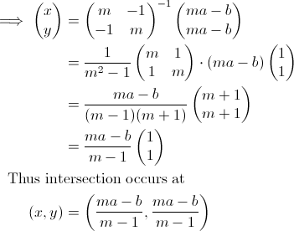

**Penrhos/MLC 2010 S2 RF 5 b** [5 marks]

Evaluate, using the substitution

dx

CodeCogsEqn (2)

**Penrhos/MLC 2010 S2 RR 18** [2, 4 marks]

A weight W is attached to a rope 16 m long that passes over a pulley at point P, 6 m above the ground. The other end of the rope is attached to a truck at a point A, 1 m above the ground, as shown in the diagram.

$$A$$

$$P$$

1 m

$$W$$

6 m

$$B$$

Show that $y=\sqrt{25+x^{2}}-11$ represents  
the distance in metres the weight is above  
point B, given x metres represents the

horizontal distance from point B to the truck.

CodeCogsEqn (3)

If the truck moves away at the rate of 3 m/s,

how fast is the weight rising when it is 2 m above the ground?

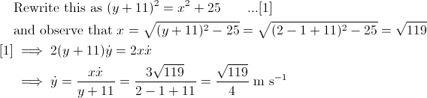

**Mt Lawley 2011 S2 RF 2 b**  [3 marks]

Evaluate

CodeCogsEqn (5)

**Mt Lawley 2011 S2 RF 5** [3, 4 marks]

A minor sector of angle $2π-θ$ is removed from a circular piece of paper of radius R. The two straight edges of the remaining major sector are pulled together to form a right circular cone, with a slant height of R.



Show that the volume of the cone is given by $V=\frac{R^{3}θ^{2}\sqrt{{4π}^{2}-θ^{2}}}{{24π}^{2}}$

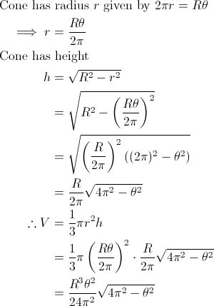

Assuming the radius, R, of the circular piece of paper to be fixed, show the exact value of θ which maximises the volume of the cone is $\frac{2\sqrt{2}π}{\sqrt{3}}$

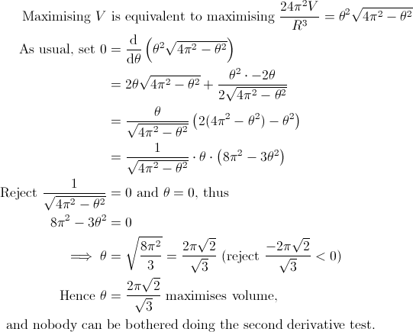

But the proof is incomplete until that is done.